**AWS Elastic Block Storage (EBS) use for MySQL data persistence on two separate EC2 instances**

Here created an EC2 instance on AWS, attached a 30GB EBS volume to it, and deployed a MySQL Docker instance on that EC2 instance. After creating and populating a database on this instance, detached the EBS volume and attached it to a second EC2 instance. Upon checking the data on the second instance, confirmed the successful migration of the MySQL database. This demonstrates how to move data between EC2 instances using EBS volumes while maintaining data integrity and availability.

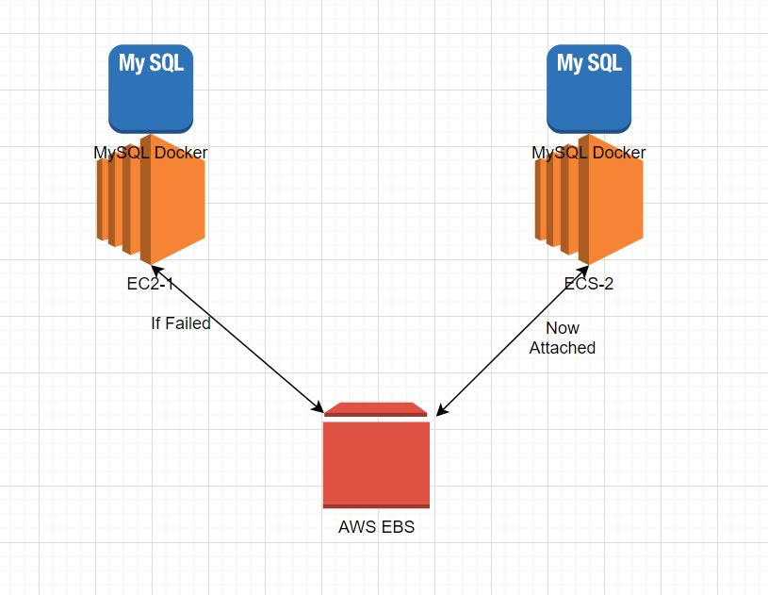

**Step 1:** Creating 2 EC2 instances on AWS

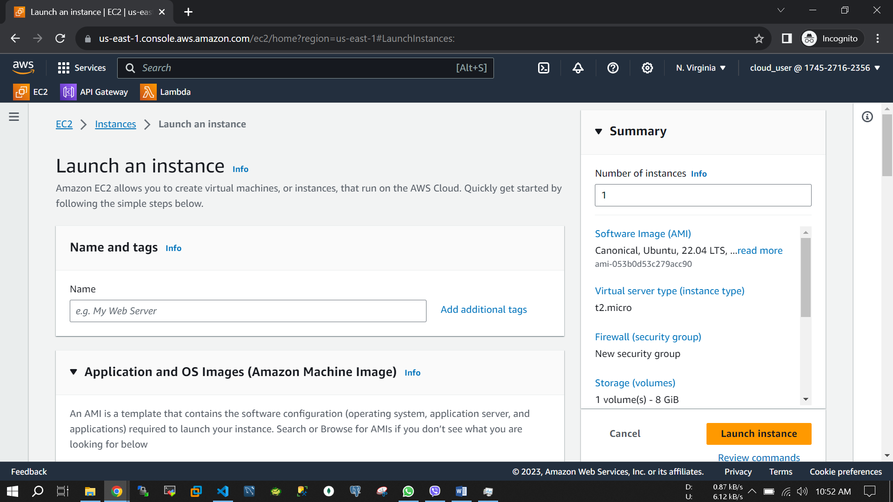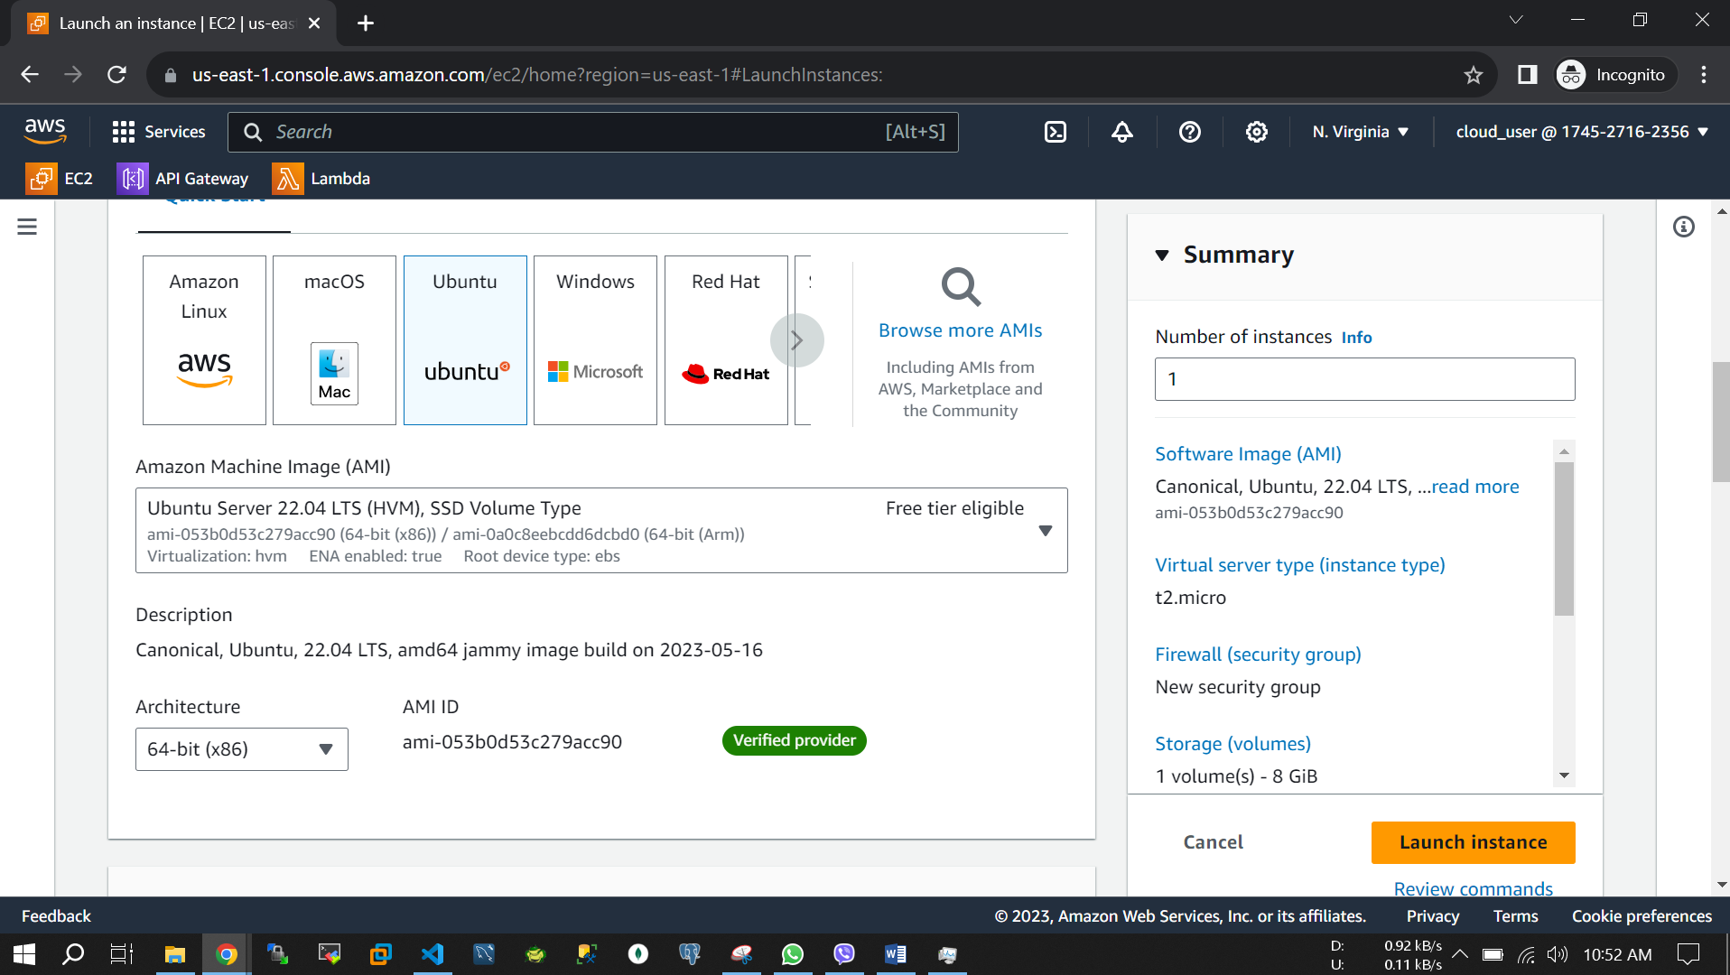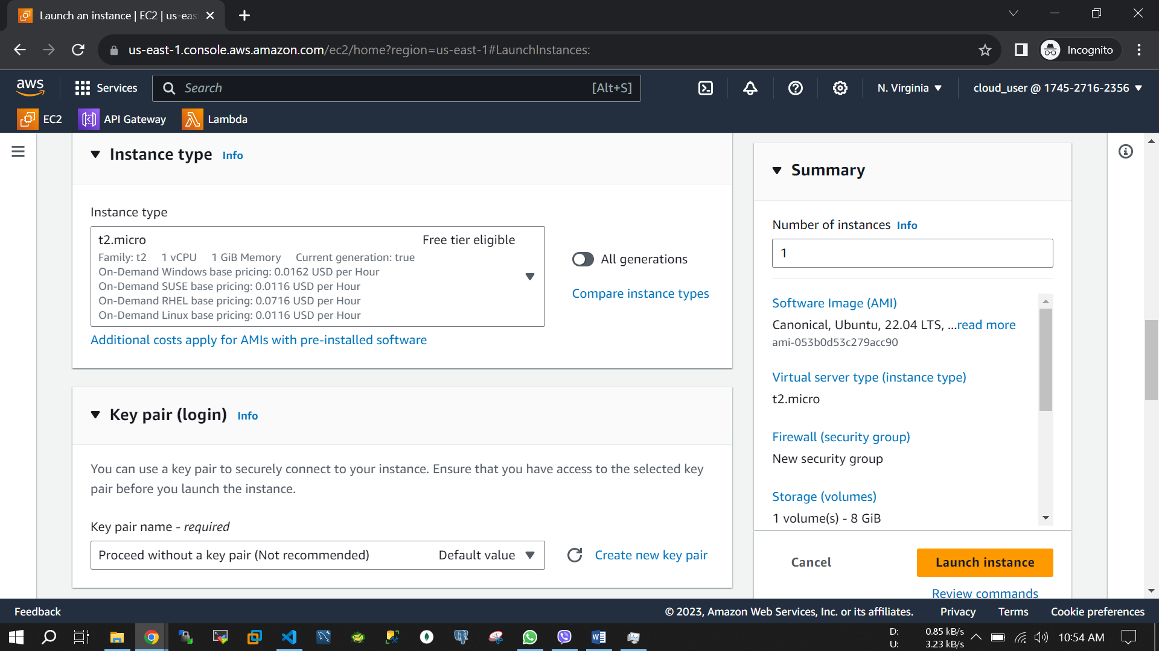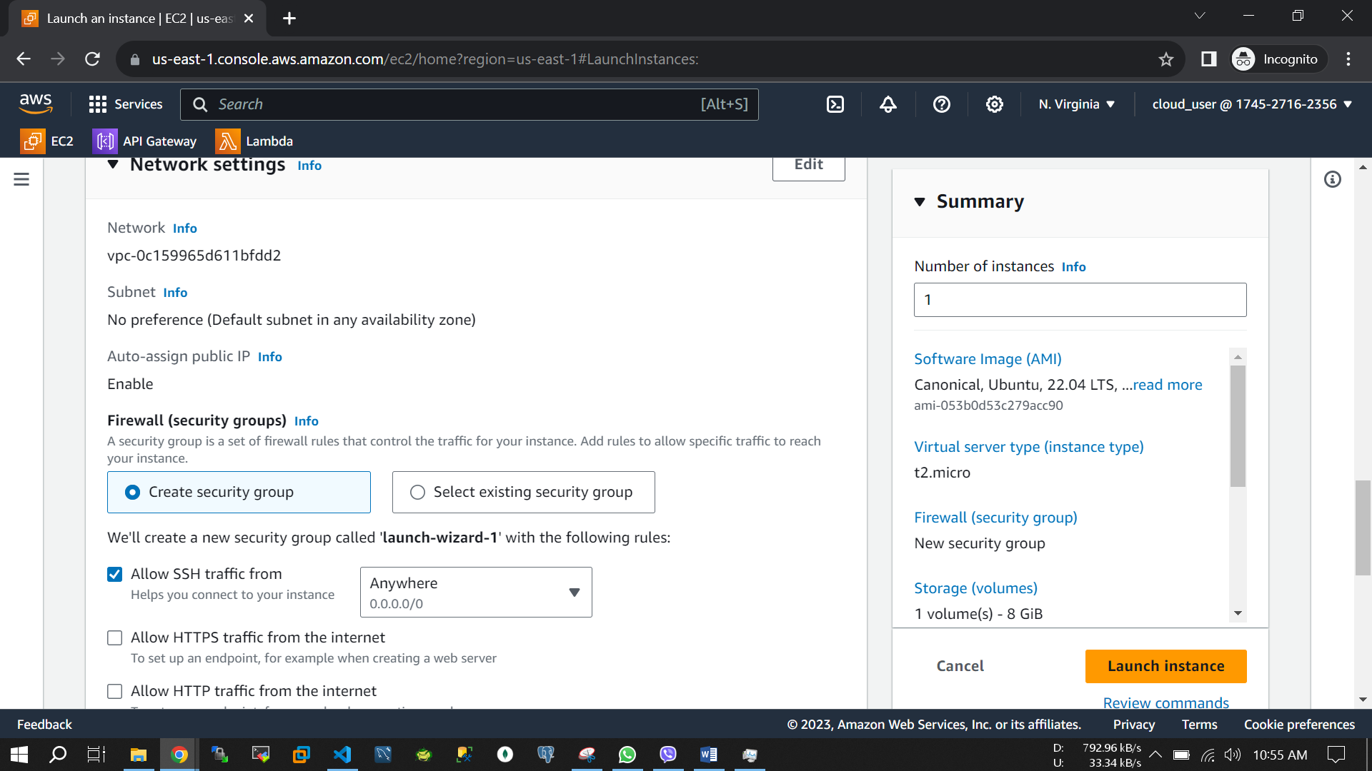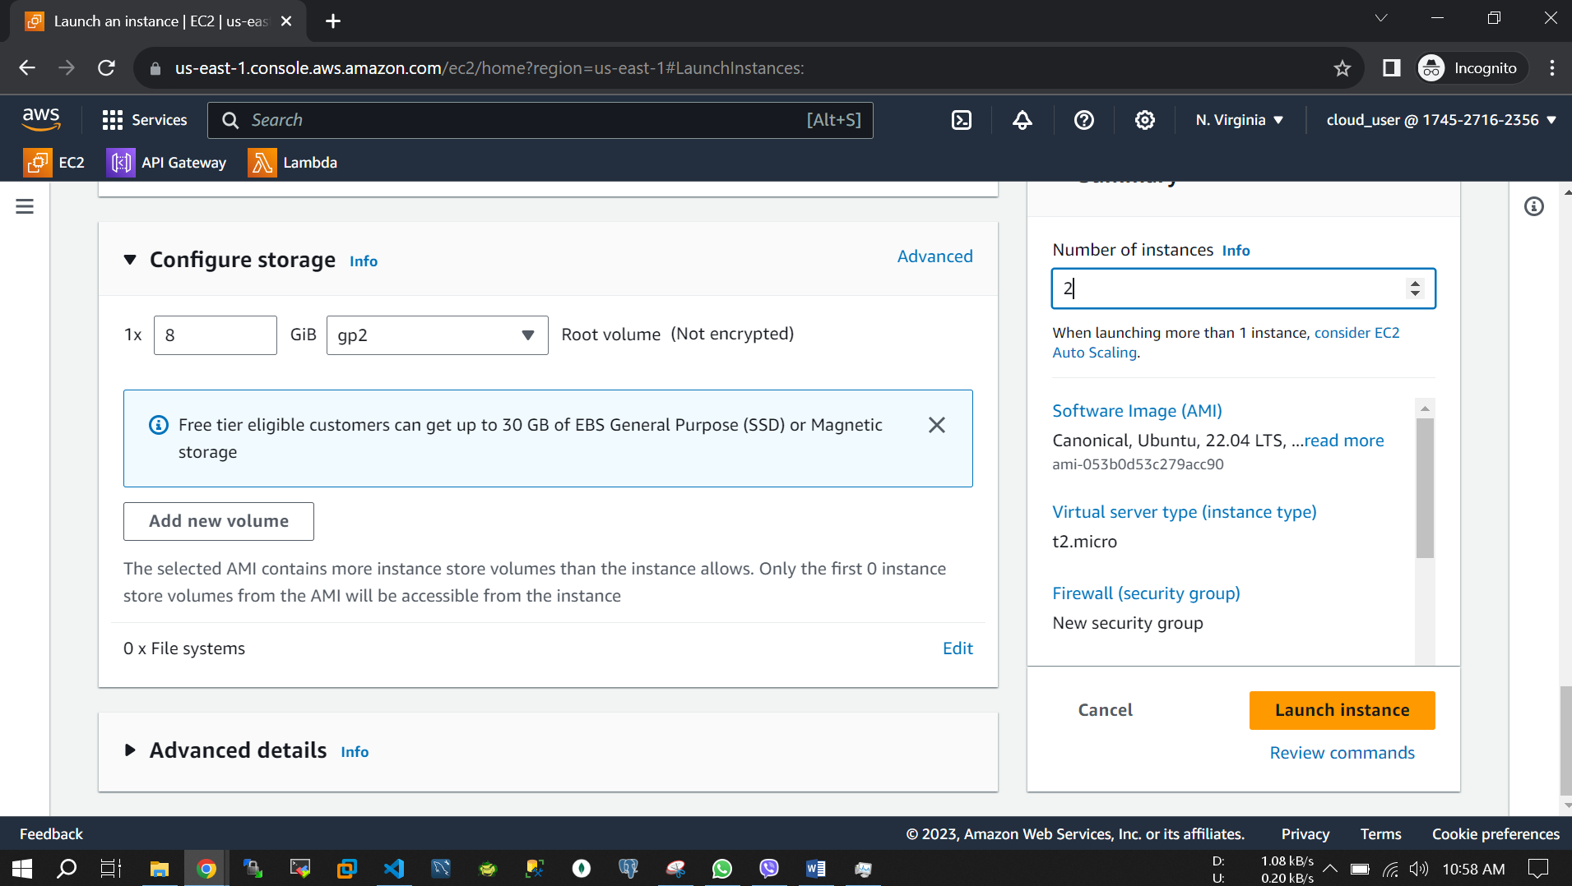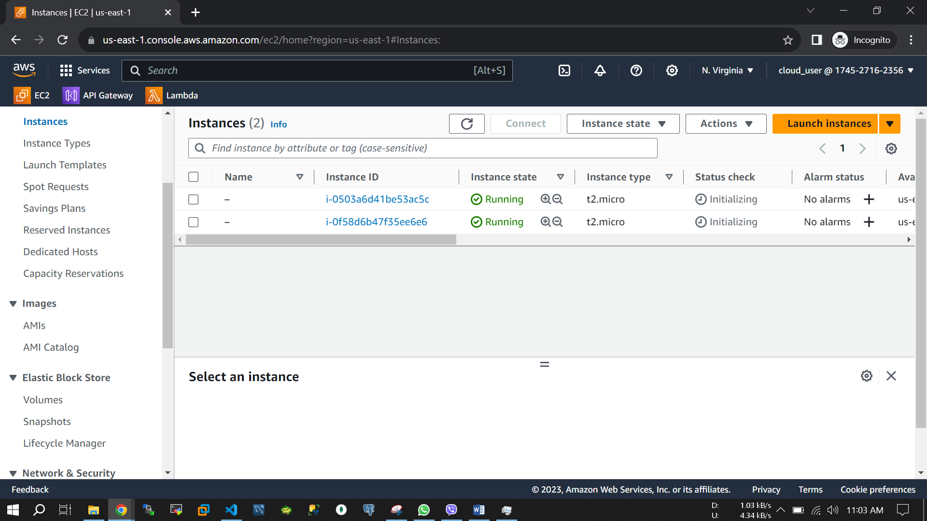Here Two EC2 instances has been created and running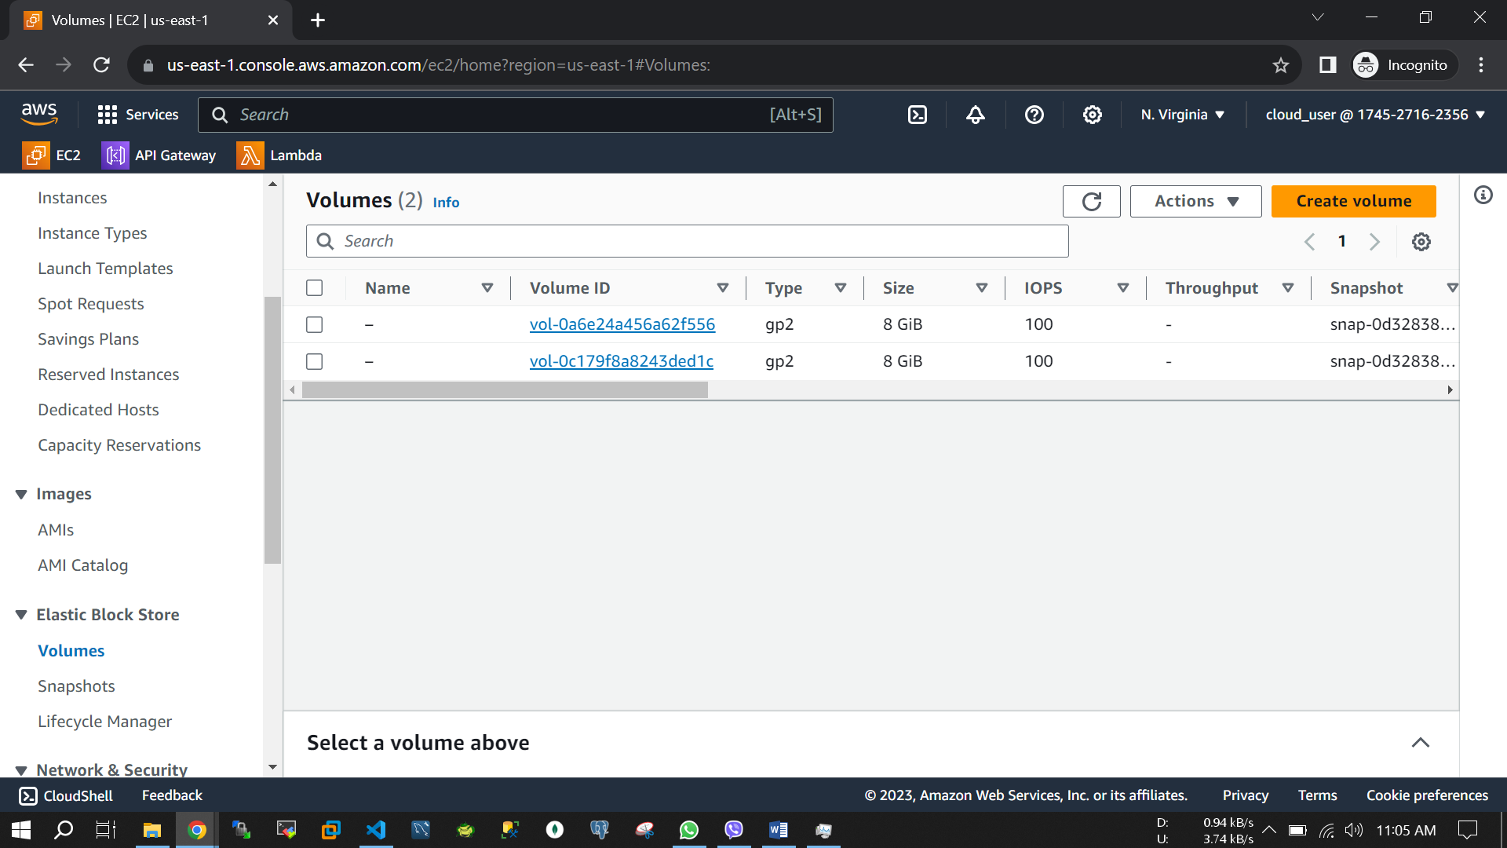

**Step 2:** Create an EBS storage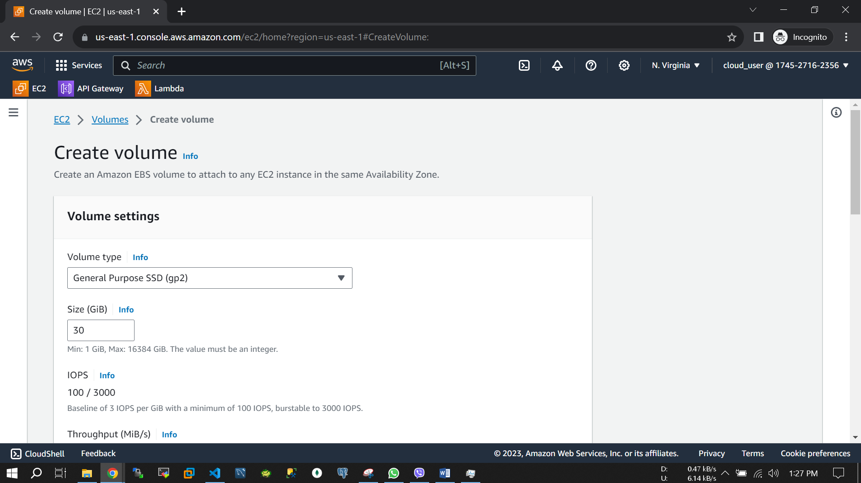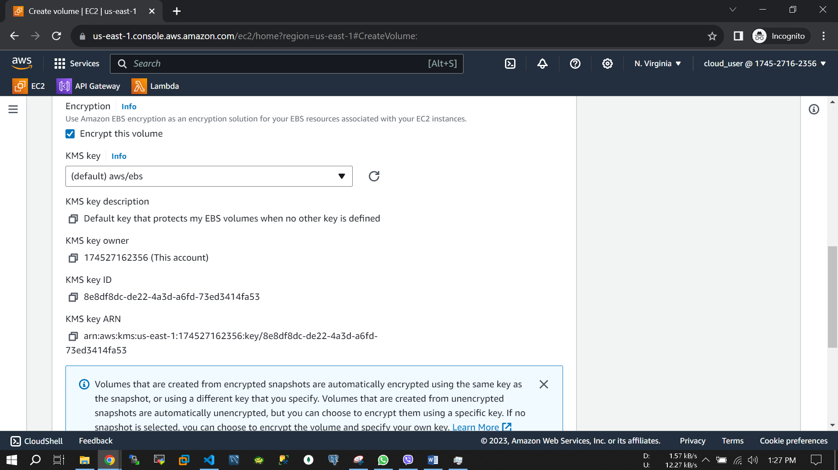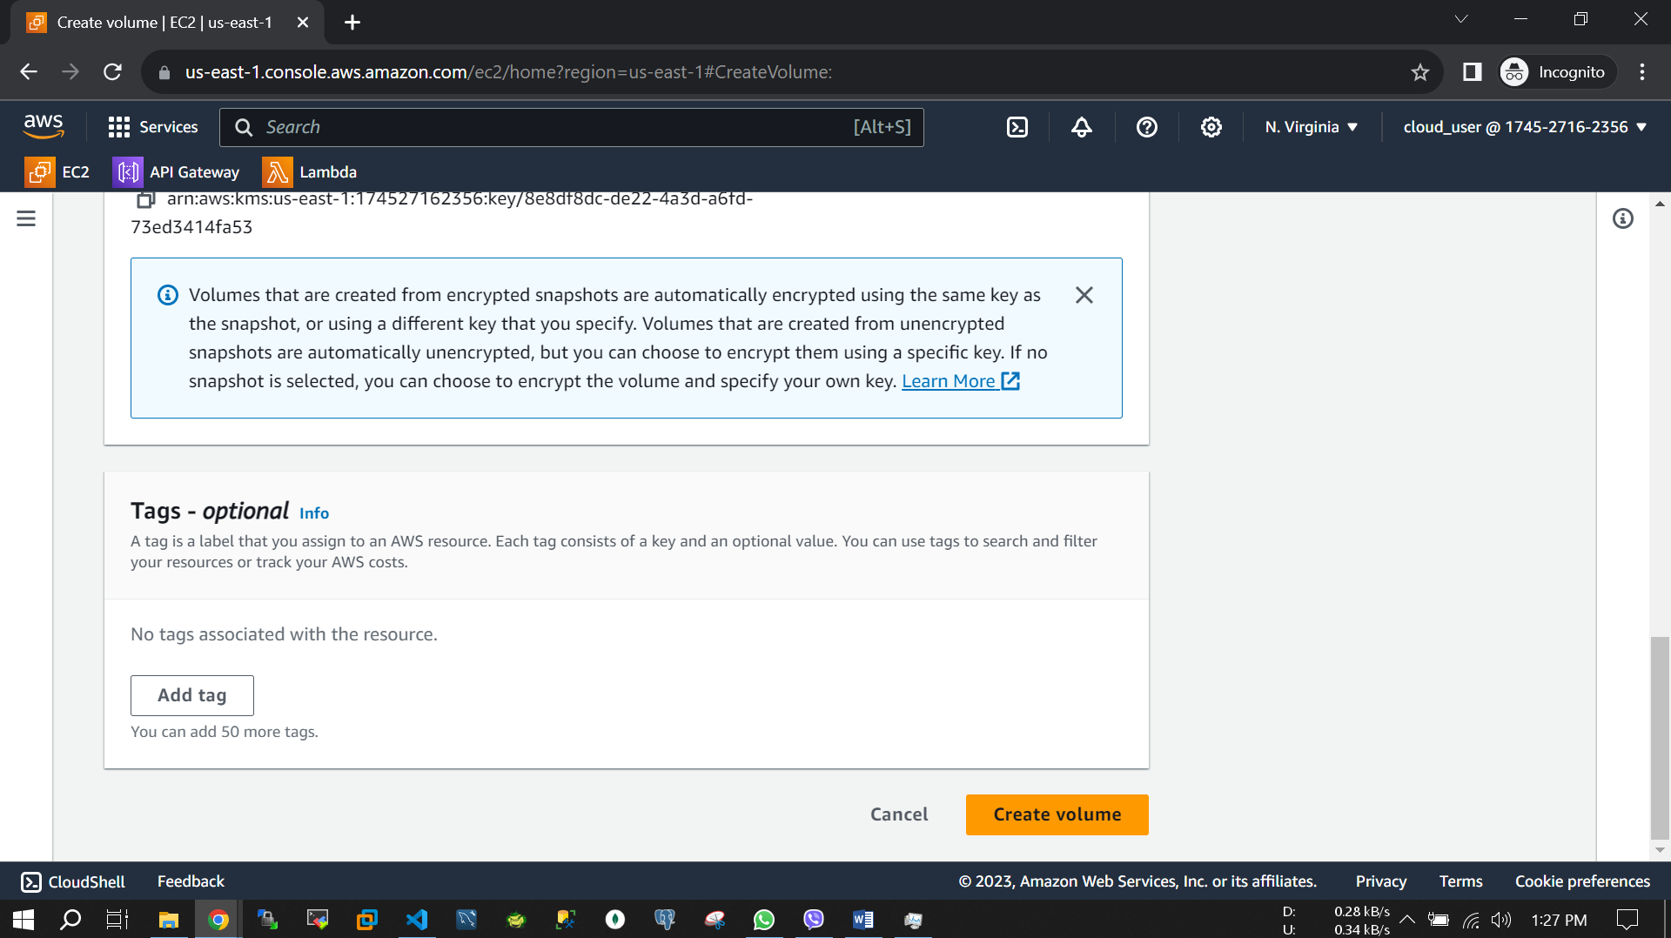

**Step 3:** Attach the EBS to 1st MySQL Ubuntu OS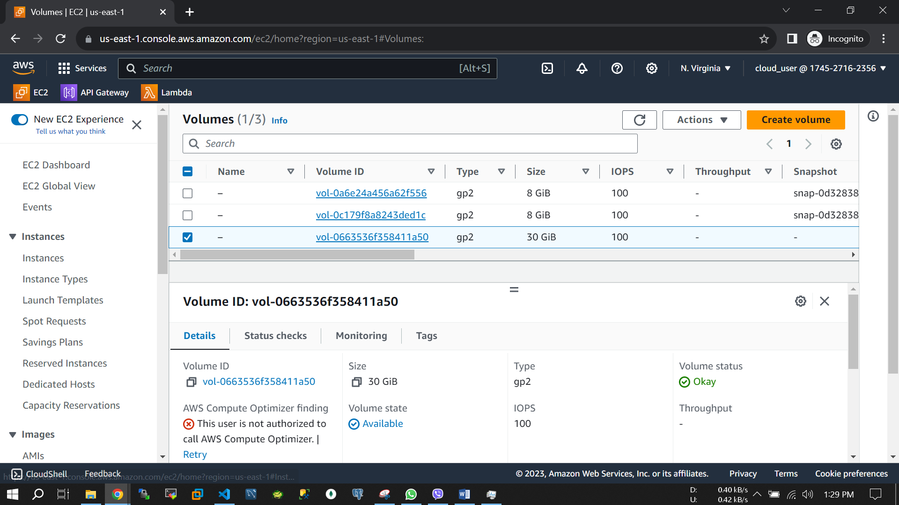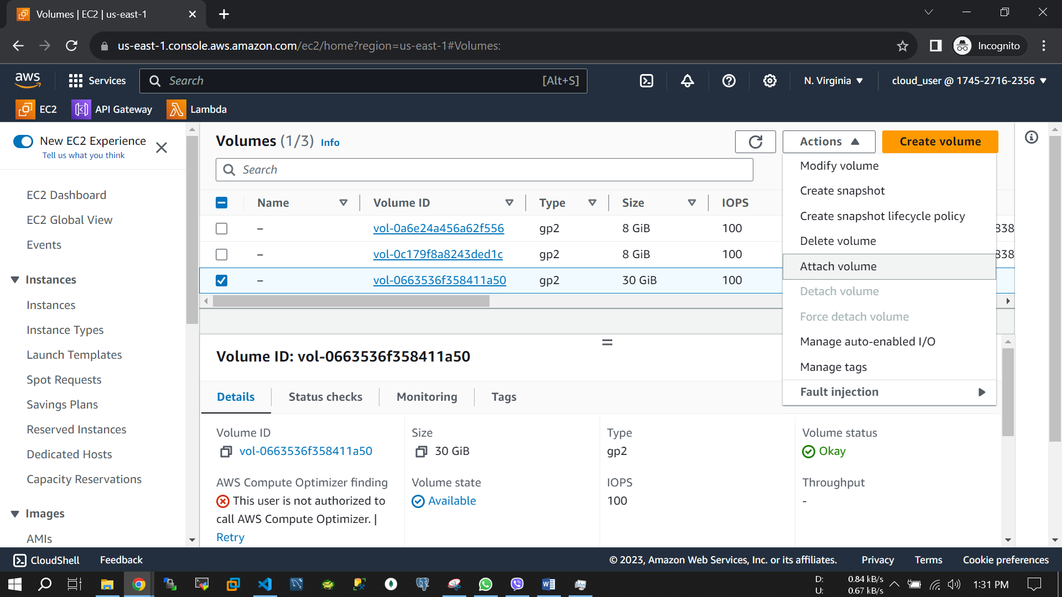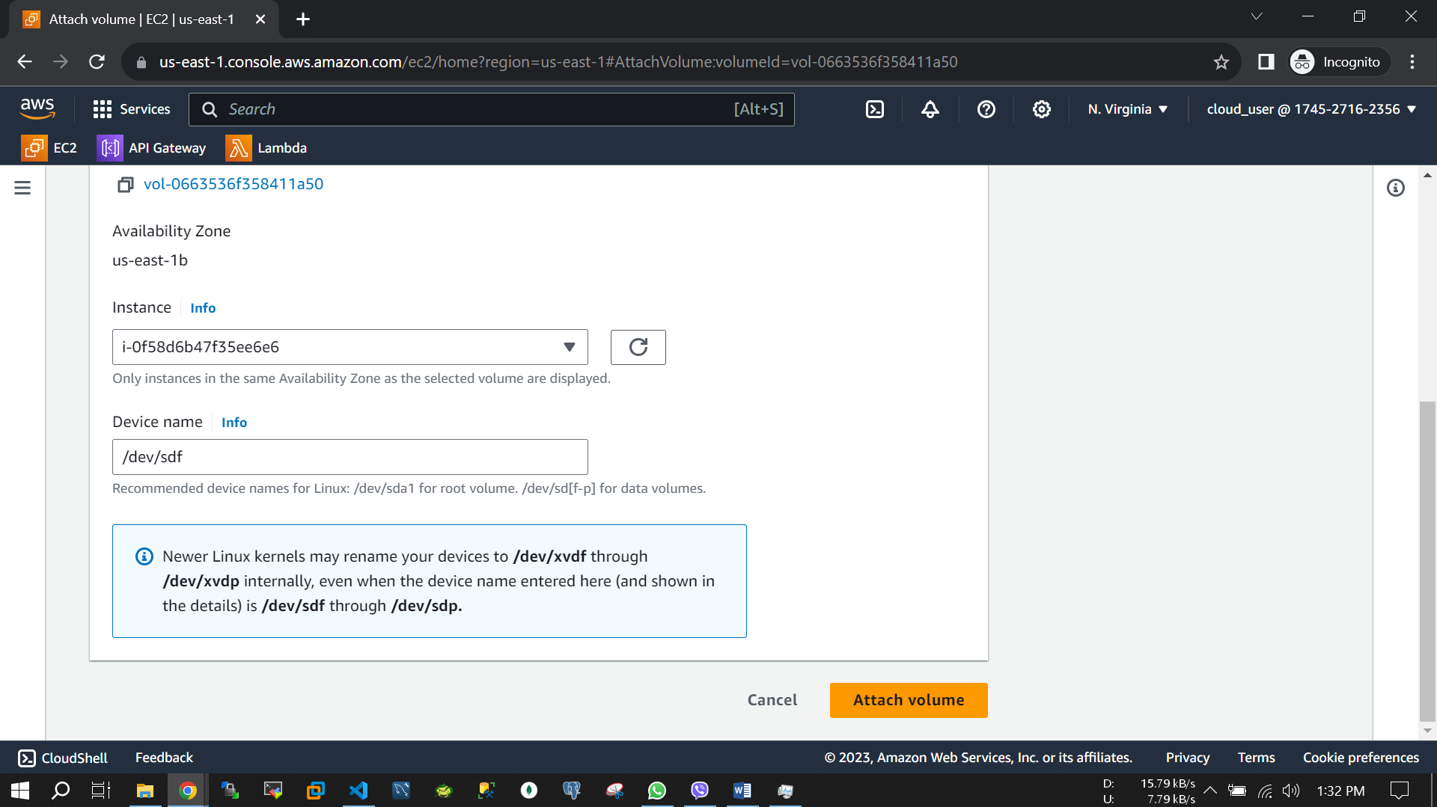

**Step 4:** Connect to 1st instance and create mount point on EBS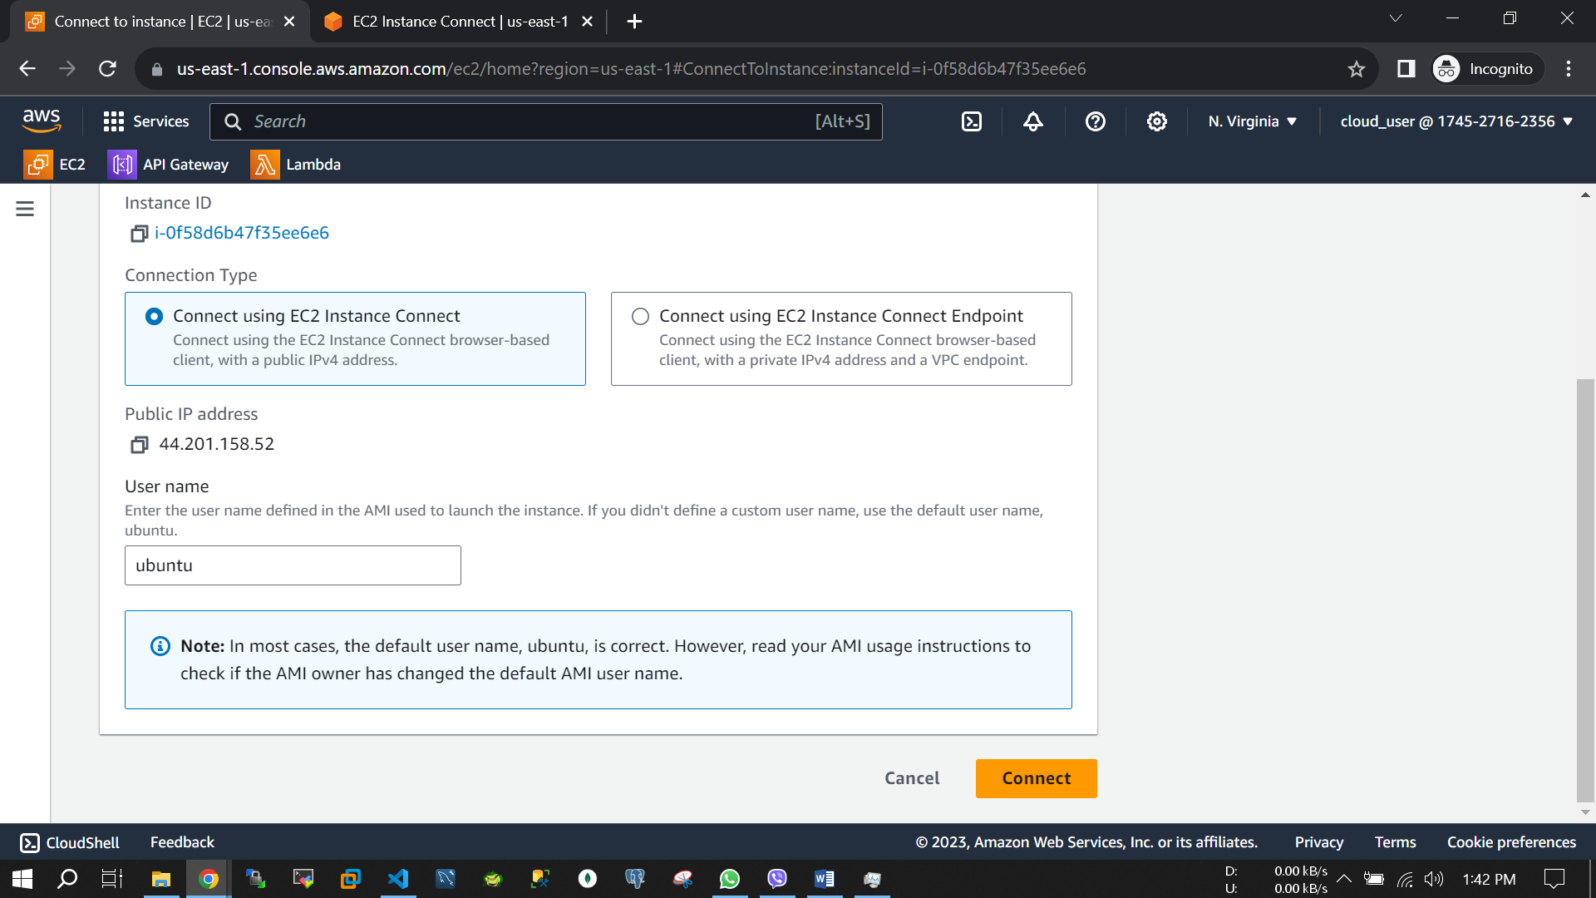

sudo apt update

sudo apt install docker.io docker-compose –y

git clone https://github.com/MdAhosanHabib/mysql-db-data-persistence.git

cd mysql-db-data-persistence

mkdir data

sudo lsblk

sudo file -s /dev/xvdf

sudo mkfs -t xfs /dev/xvdf

sudo mount /dev/xvdf /home/ubuntu/mysql-db-data-persistence/data

sudo docker-compose up -d

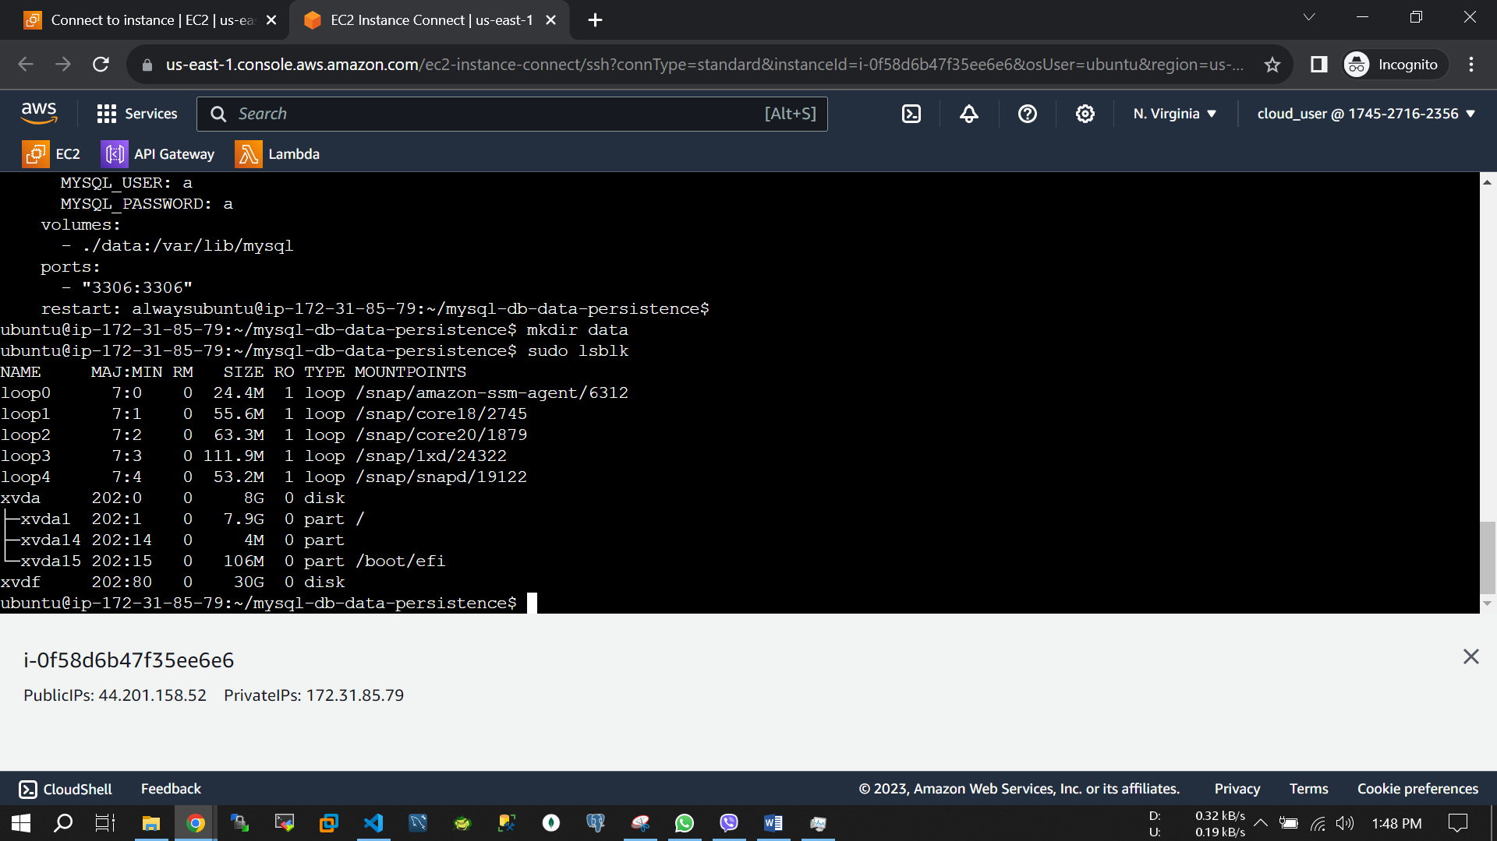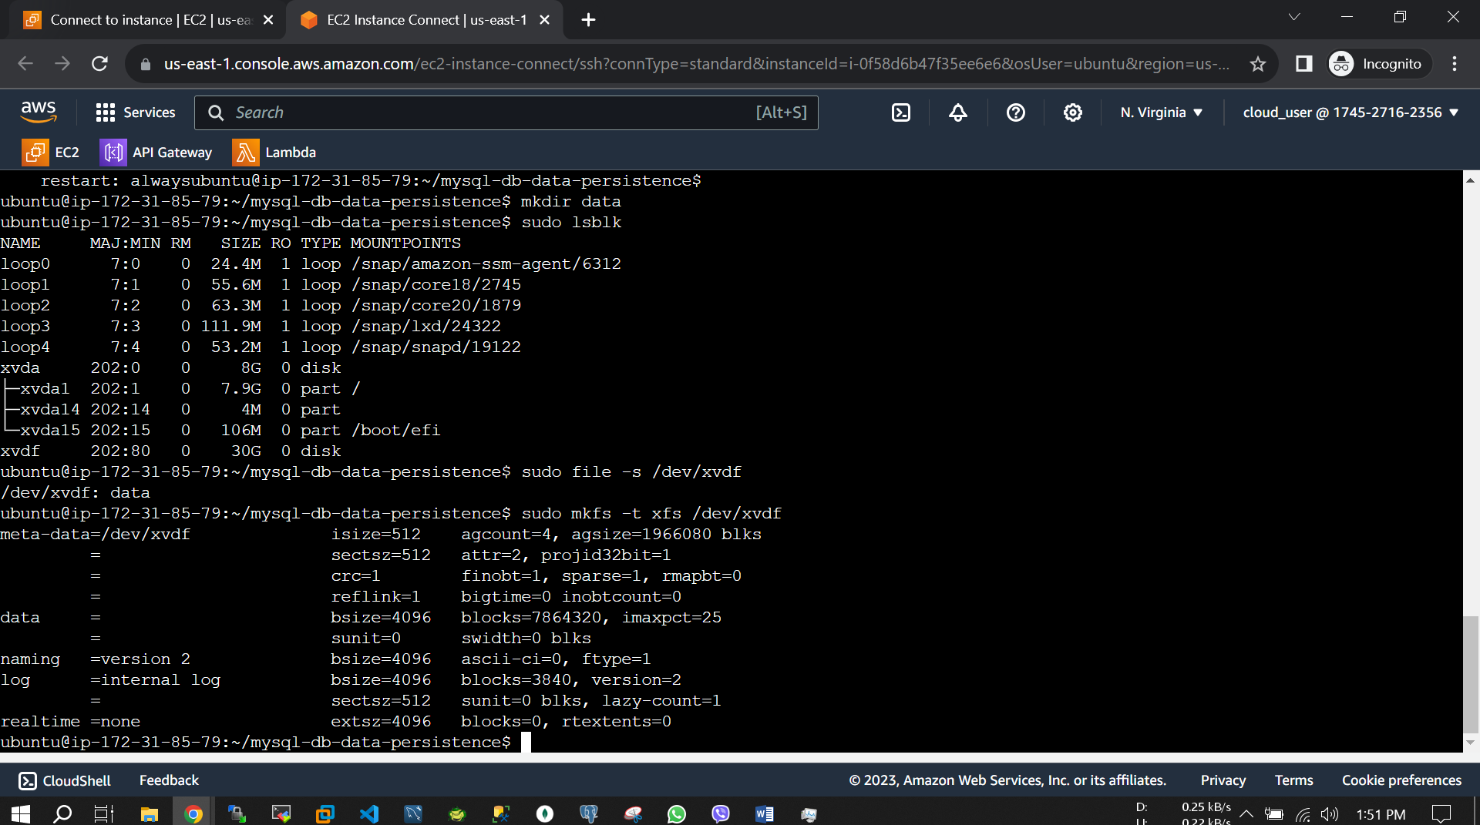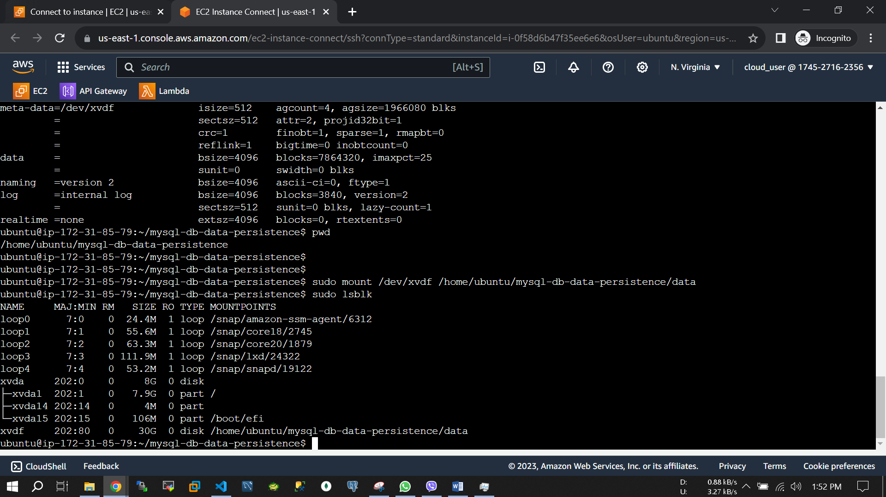

Step 5: Create test database on 1st instance

sudo docker exec -it db bash

mysql -root -p a

show databases;

create database ahosan;

show databases;

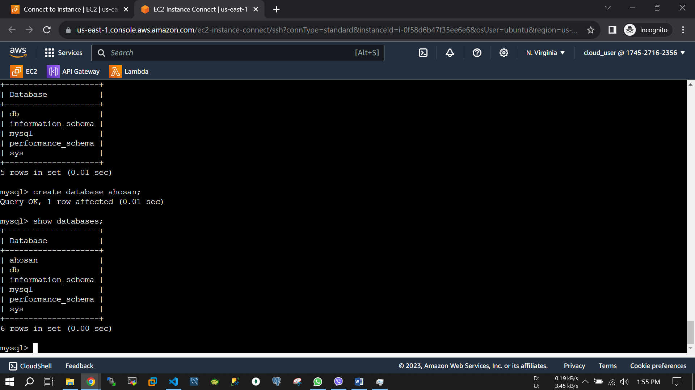

Step 6: Detach the EBS and attach to 2nd instance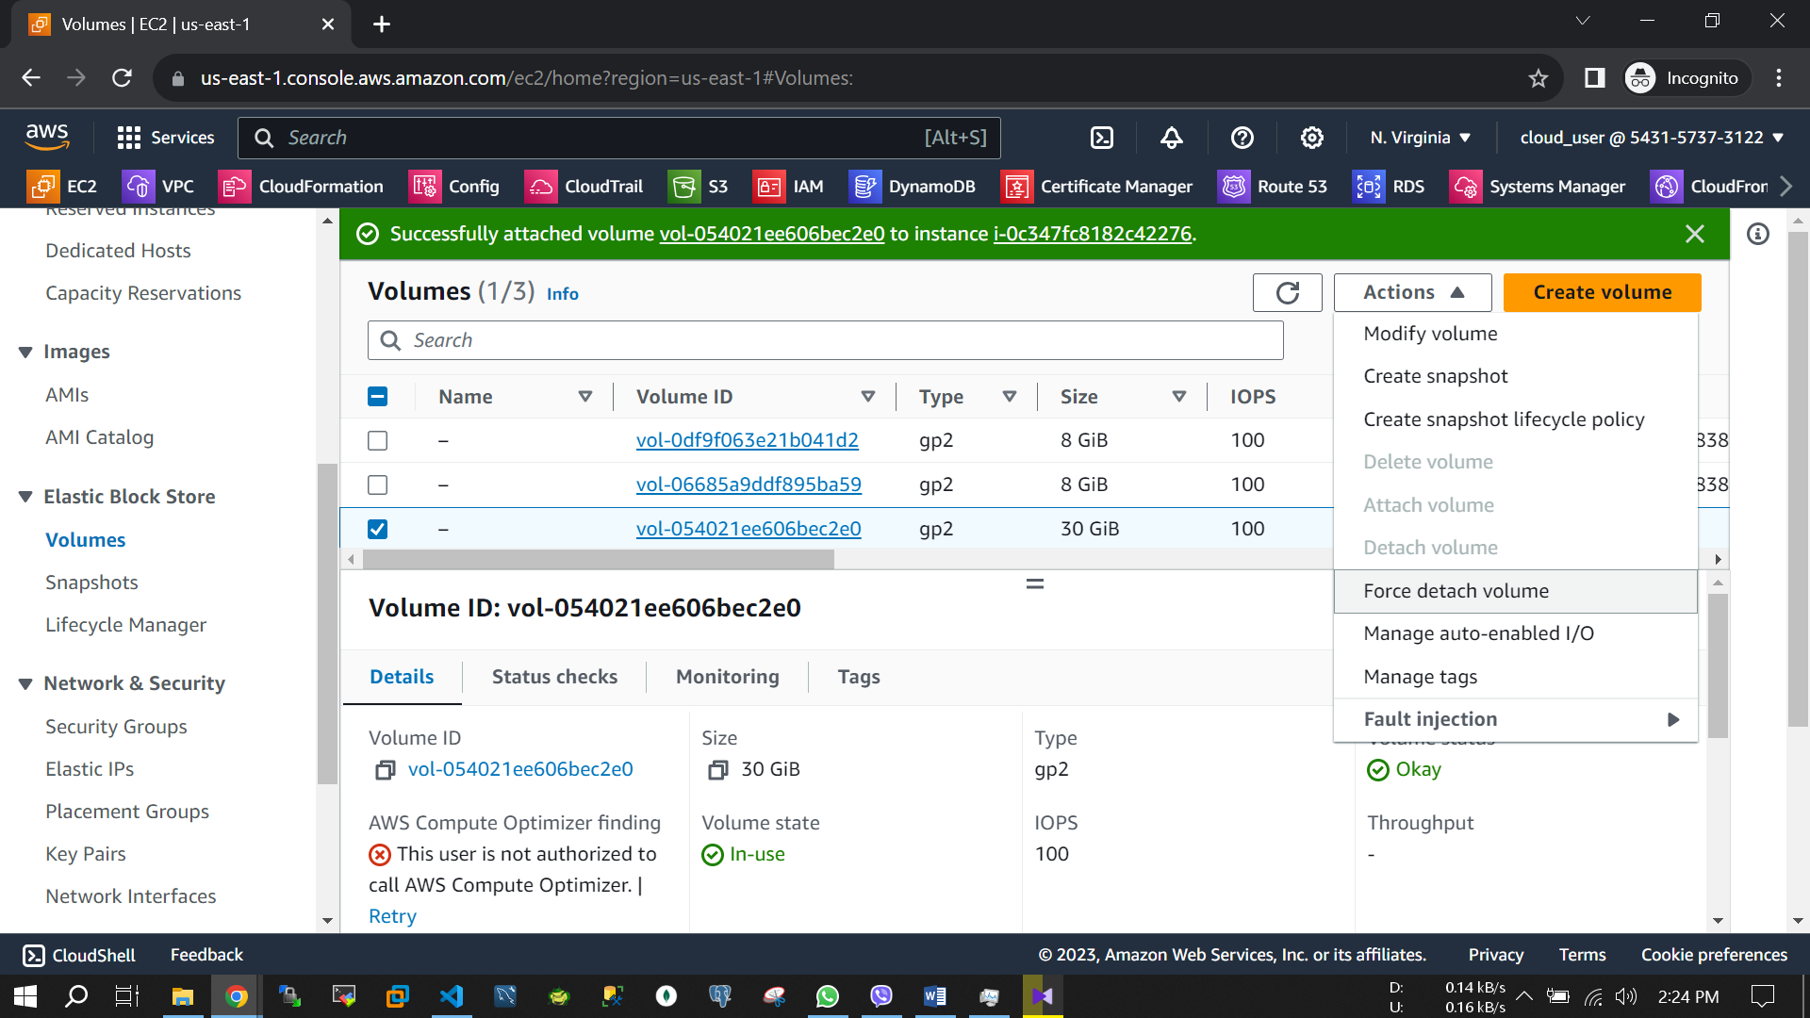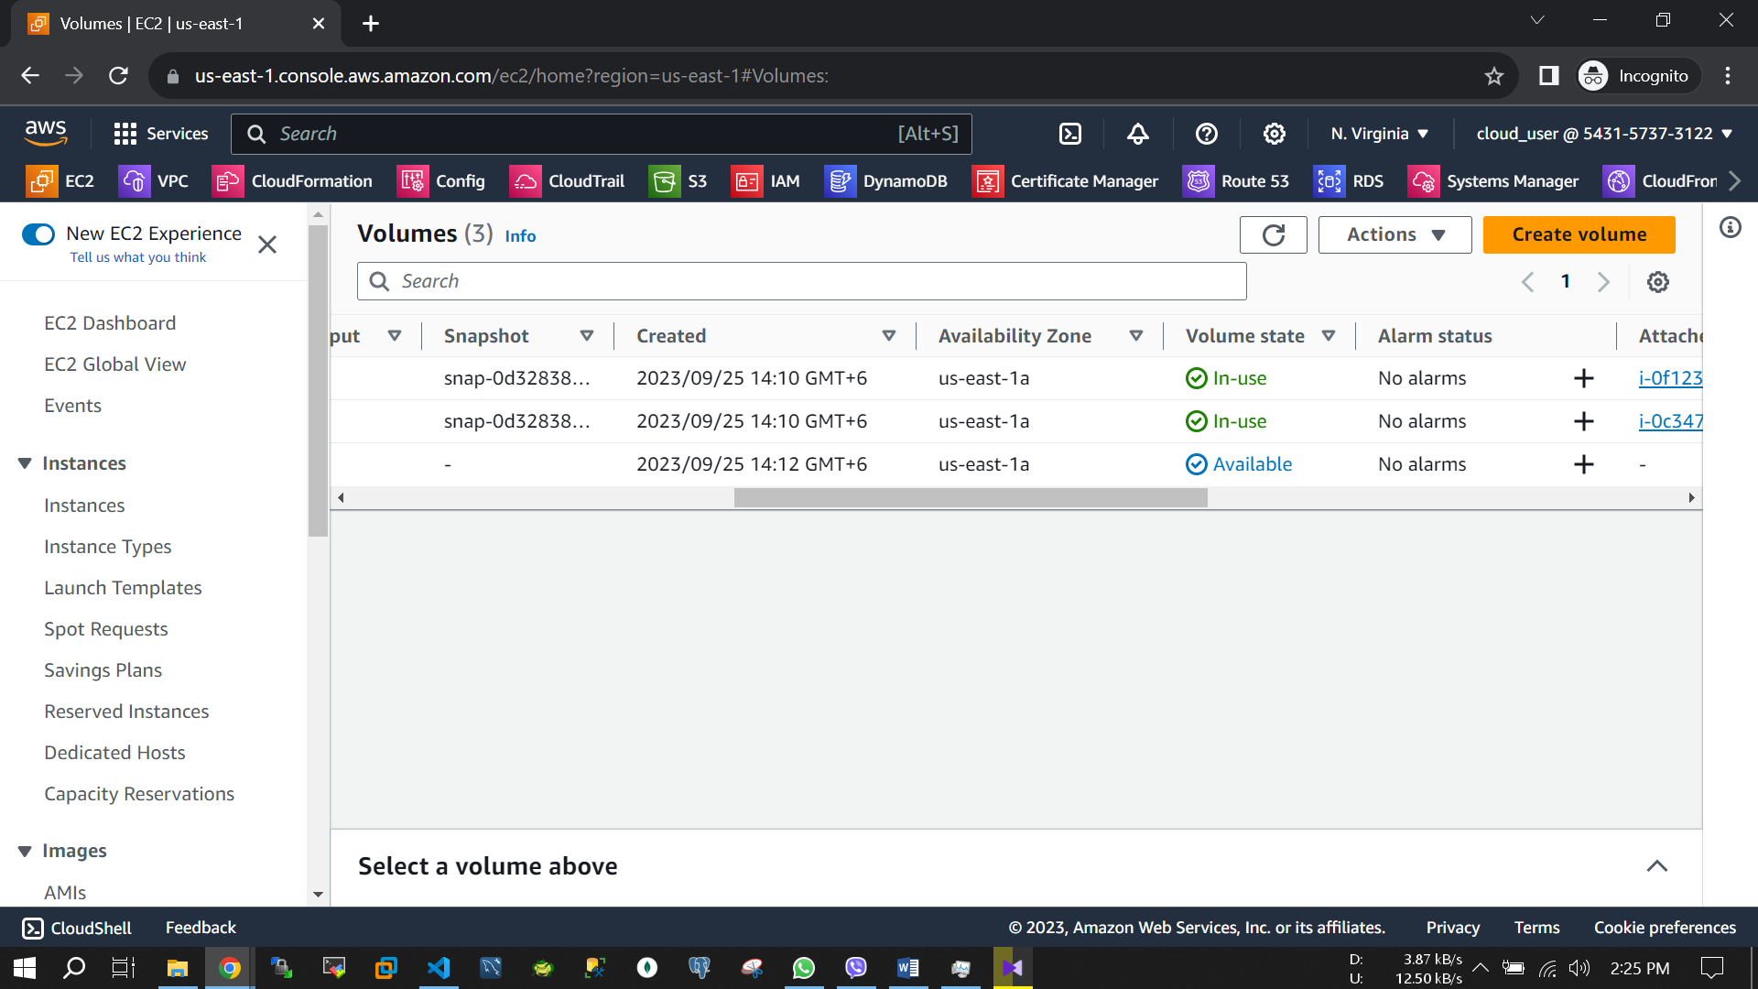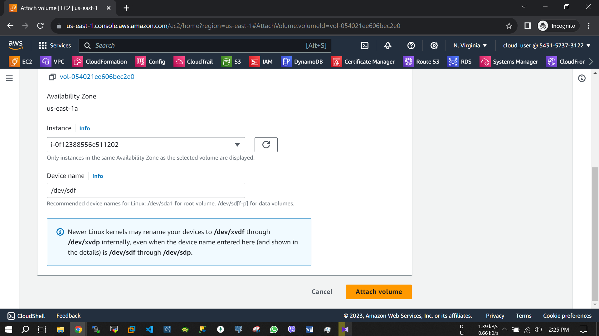

Step 7: Create mount point on EBS and set MySQL to retrieve the created Database

sudo apt update

sudo apt install docker.io docker-compose –y

git clone https://github.com/MdAhosanHabib/mysql-db-data-persistence.git

cd mysql-db-data-persistence

mkdir data

sudo lsblk

sudo mount /dev/xvdf /home/ubuntu/mysql-db-data-persistence/data

sudo docker-compose up -d

sudo docker exec -it db bash

mysql -root -p a

show databases;

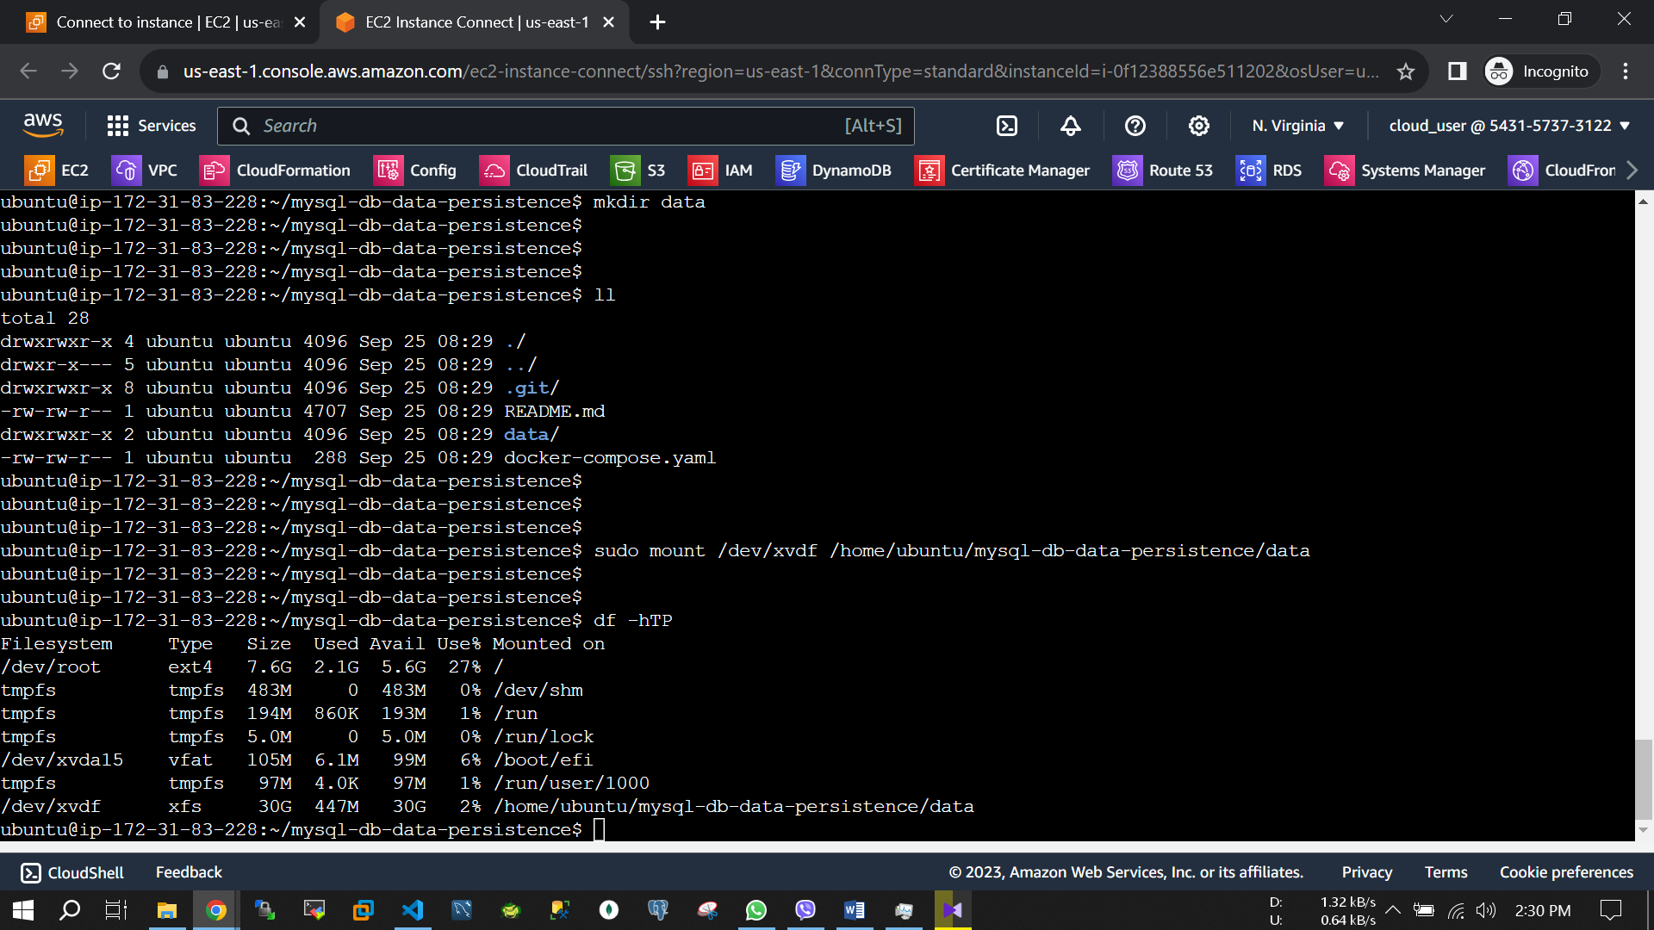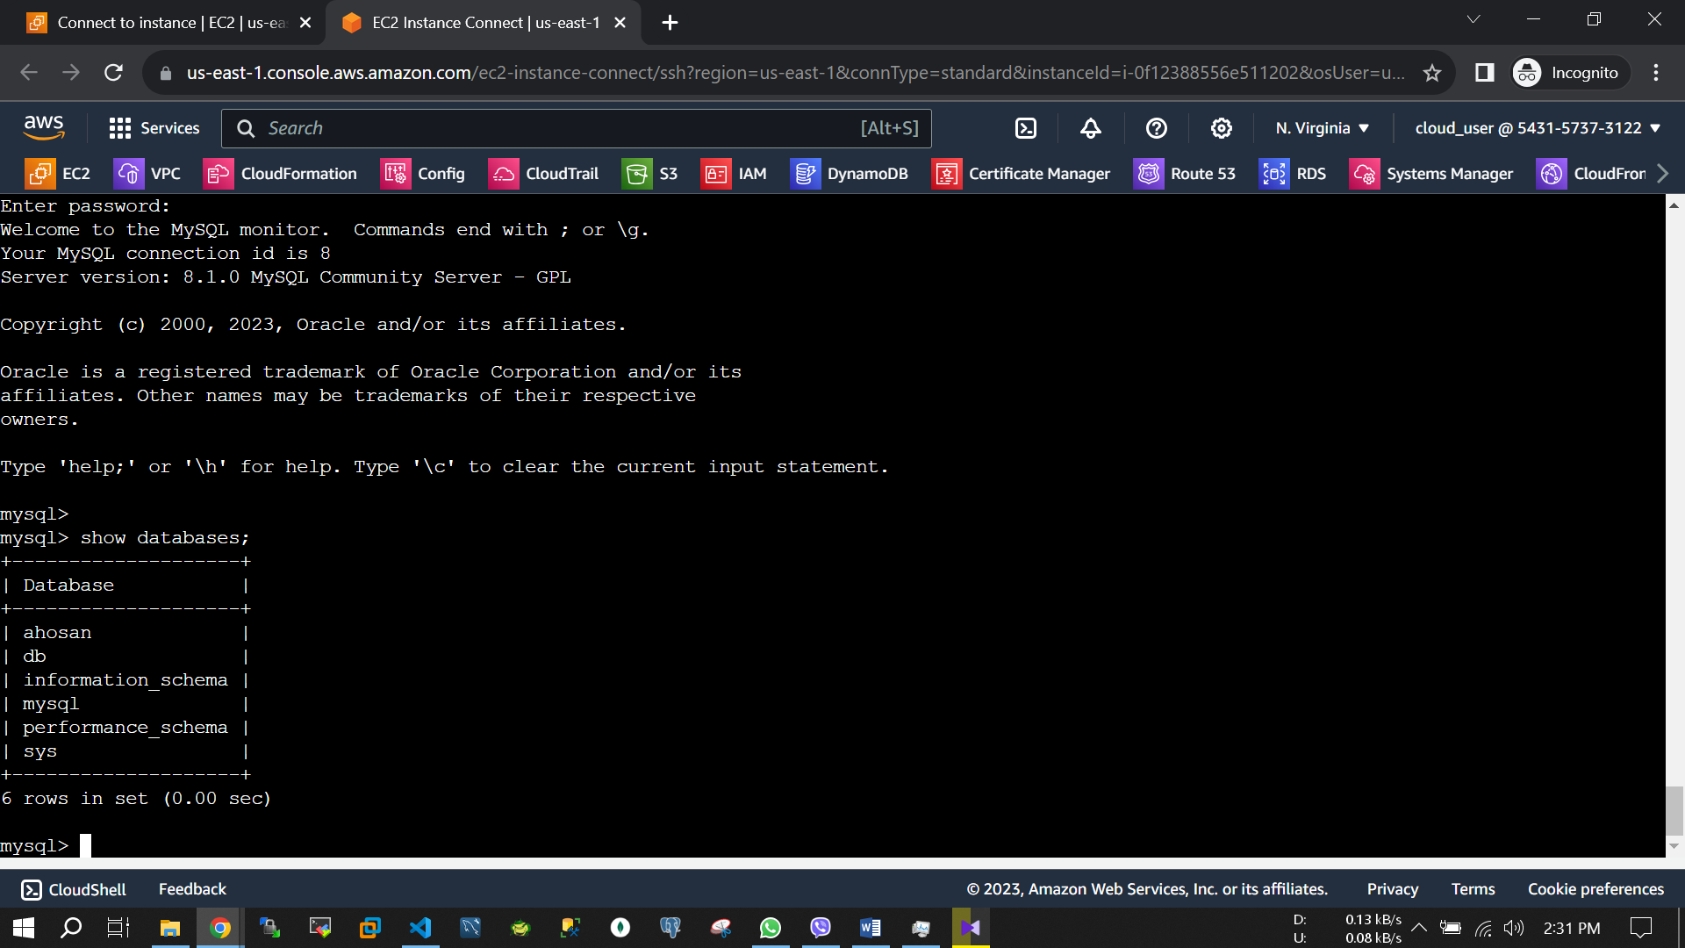

Data are same as Instance 1, Thanks from Ahosan Habib.